13) overload a function to calculate the sum of two matrices

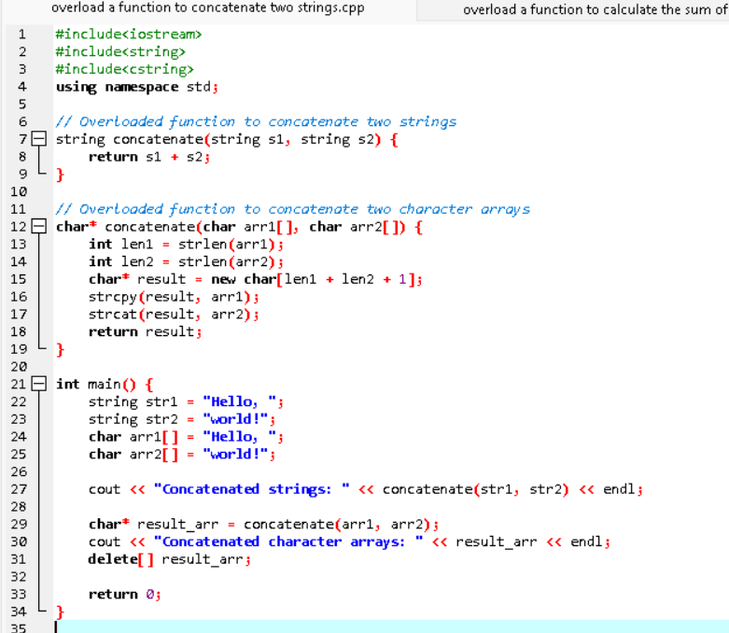

14) overload a function to print an integer array, a double array and a character array

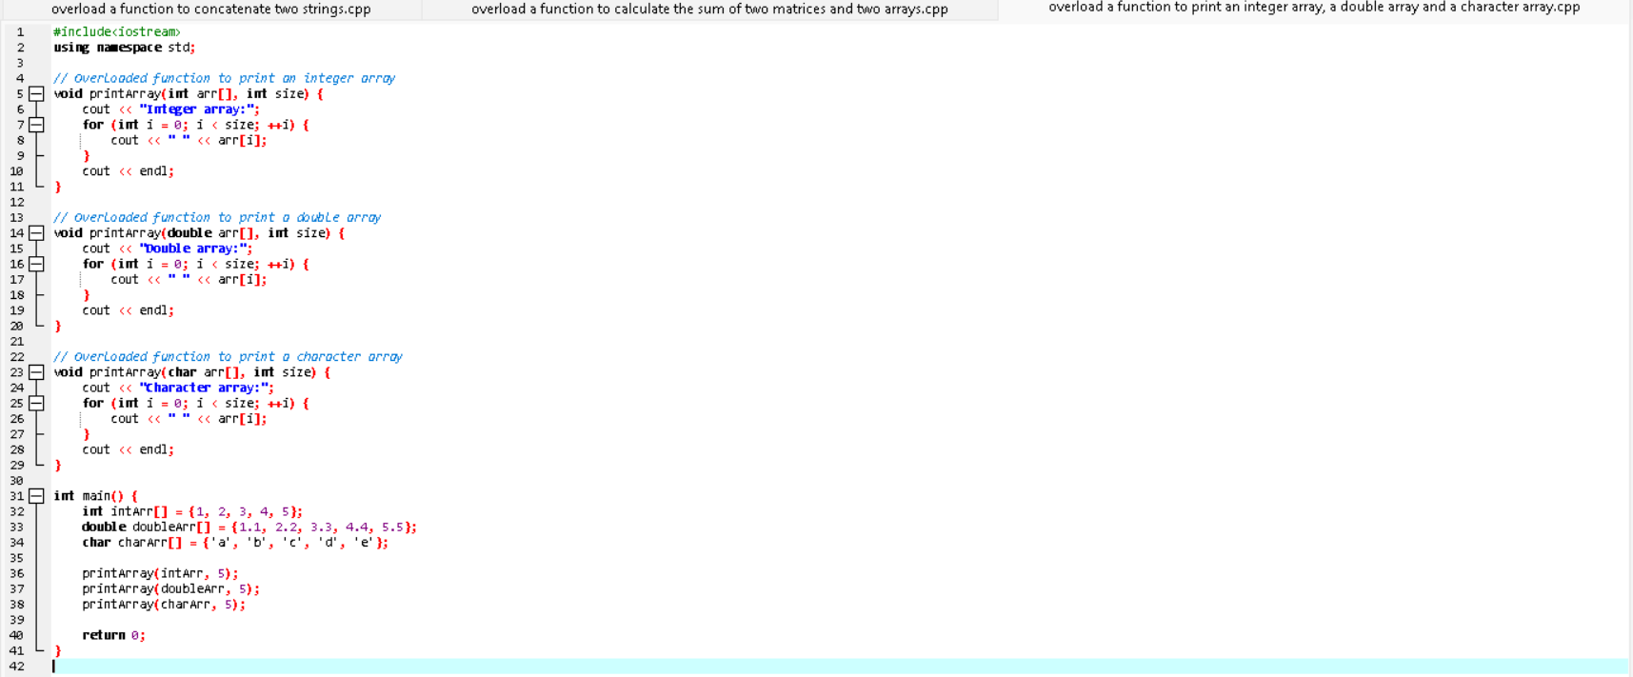

15) overload a function to find a factorial of an integer number and factorial of a floating-point number

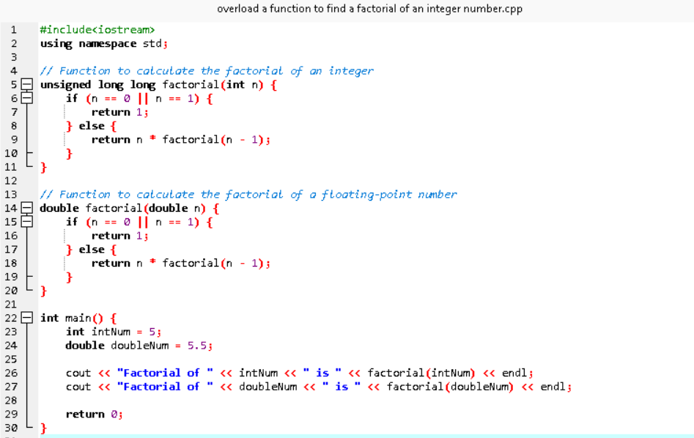

16) overload a function to sort an integer array and a double array

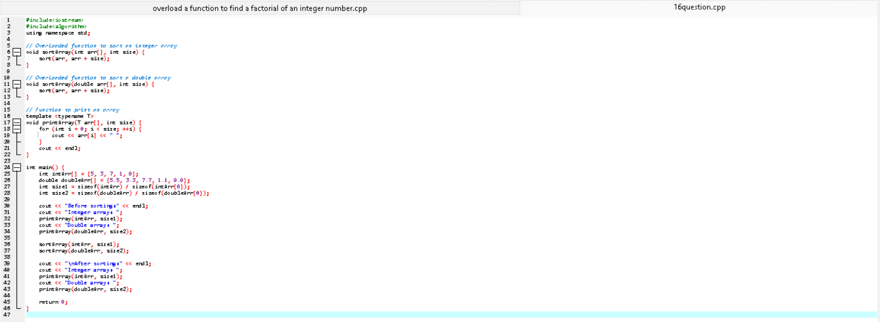17) overload a function to calculate the power of an integer number and power of a floating-point number separately

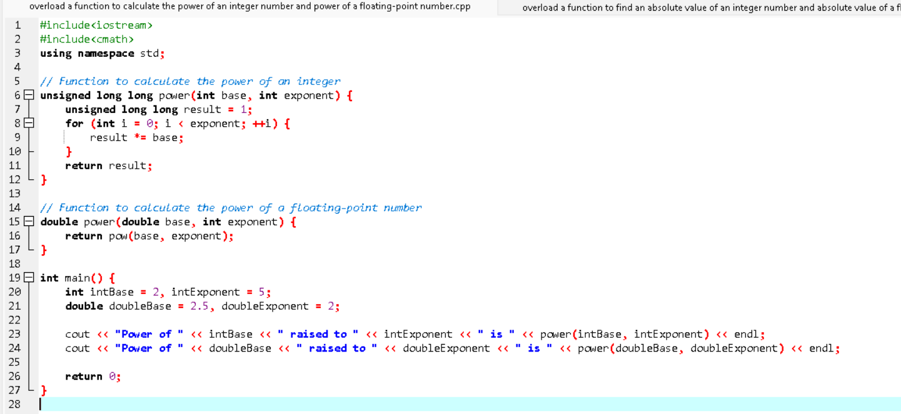18) overload a function to find an absolute value of an integer number and absolute value of a floating-point number separately

